Data Communication and Networks

Lab experiment 02

Name - Naman Dixit

Sap ID - 500125539

Batch - 7 Data Science

Question 1. Mechanics and workingsos bus, star, and mash topology

Ans

**Bus Topology:-**

Bus topology is a network configuration where all devices share a single communication line (backbone cable). Here's a detailed explanation:

Basic Structure:

* All devices (nodes) are connected to a single central cable called the backbone or bus
* Each device has a unique identifier/address
* Data flows in both directions along the bus
* Terminators are placed at both ends of the cable to absorb signals and prevent reflection

Working Mechanism:

1. Data Transmission

* When a device wants to send data, it puts the data and destination address on the bus
* The data signal travels in both directions along the bus
* All devices on the network can see the data
* Only the device matching the destination address accepts and processes the data
* Other devices ignore the transmission

1. Access Control

* Uses CSMA (Carrier Sense Multiple Access) protocol
* Before transmitting, devices check if the bus is free
* If the bus is busy, devices wait and try again later
* Collisions can occur if two devices transmit simultaneously
* When collisions happen, devices stop transmission and retry after a random time interval

Advantages:

1. Simple and cost-effective to implement
2. Easy to extend by adding new devices
3. Requires less cable compared to other topologies
4. Works well for small networks

Disadvantages:

1. Limited cable length and number of stations
2. If the main cable fails, entire network fails
3. Performance degrades as network traffic increases
4. Difficult to troubleshoot
5. Signal becomes weaker over distance (attenuation)

Performance Considerations:

* Data transmission speed depends on the cable type used
* Maximum cable length is limited due to signal degradation
* Number of nodes affects network performance
* Distance between nodes impacts signal quality
* Proper termination is crucial to prevent signal reflection

Uses:

* Small office networks
* School computer labs
* Simple industrial control systems
* Legacy Ethernet networks (10Base-2, 10Base-5)

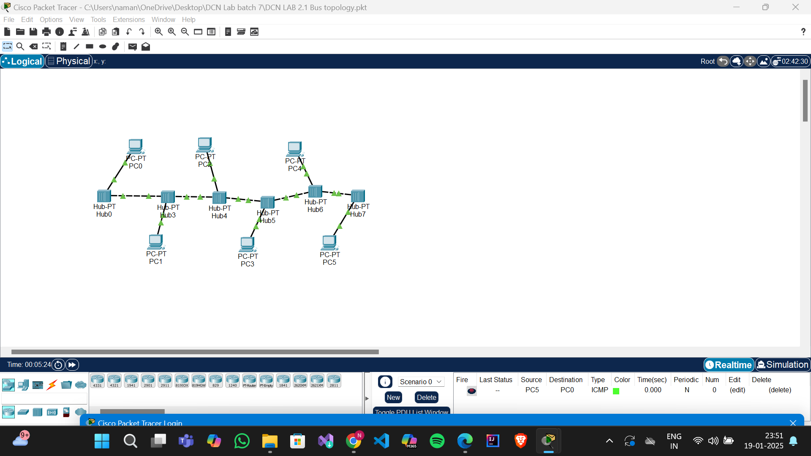

**Star Topology:-**

Basic Structure:

* All devices connect directly to a central hub/switch
* Each device has its own dedicated connection to the hub
* The central hub manages and controls all network traffic
* No direct device-to-device connections exist

Working Mechanism:

1. Data Transmission

* When a device sends data, it first goes to the central hub
* The hub examines the destination address
* Data is then forwarded only to the intended recipient
* Other devices don't see the transmission unless it's meant for them
* Each transmission uses a dedicated path

1. Central Hub Functions

* Acts as a traffic controller
* Manages data flow between devices
* Can be either passive (hub) or active (switch)
* Switches are smarter and create direct virtual connections
* Can detect and manage network errors

Advantages:

1. Easy to install and wire
2. Simple to detect and isolate faults
3. Easy to add or remove devices
4. Device failure doesn't affect other nodes
5. Better performance due to dedicated connections
6. Centralized management and security

Disadvantages:

1. Relies heavily on central hub (single point of failure)
2. Requires more cable than bus topology
3. Hub failure affects entire network
4. More expensive due to hub cost and cabling
5. Limited by hub capacity

Performance Considerations:

* Network speed depends on hub/switch capabilities
* Each device gets full bandwidth on its connection
* No collision domains with switches
* Distance limitations based on cable type
* Can be cascaded to extend network size

Implementation Types:

1. Active Star

* Uses powered hub/switch
* Can regenerate signals
* Provides better performance
* Supports longer distances

1. Passive Star

* Uses unpowered hub
* Simply connects cables
* Limited distance range
* Lower cost option

Common Uses:

* Modern office networks
* Home networks
* School networks
* Most Ethernet LANs
* Small to large business networks

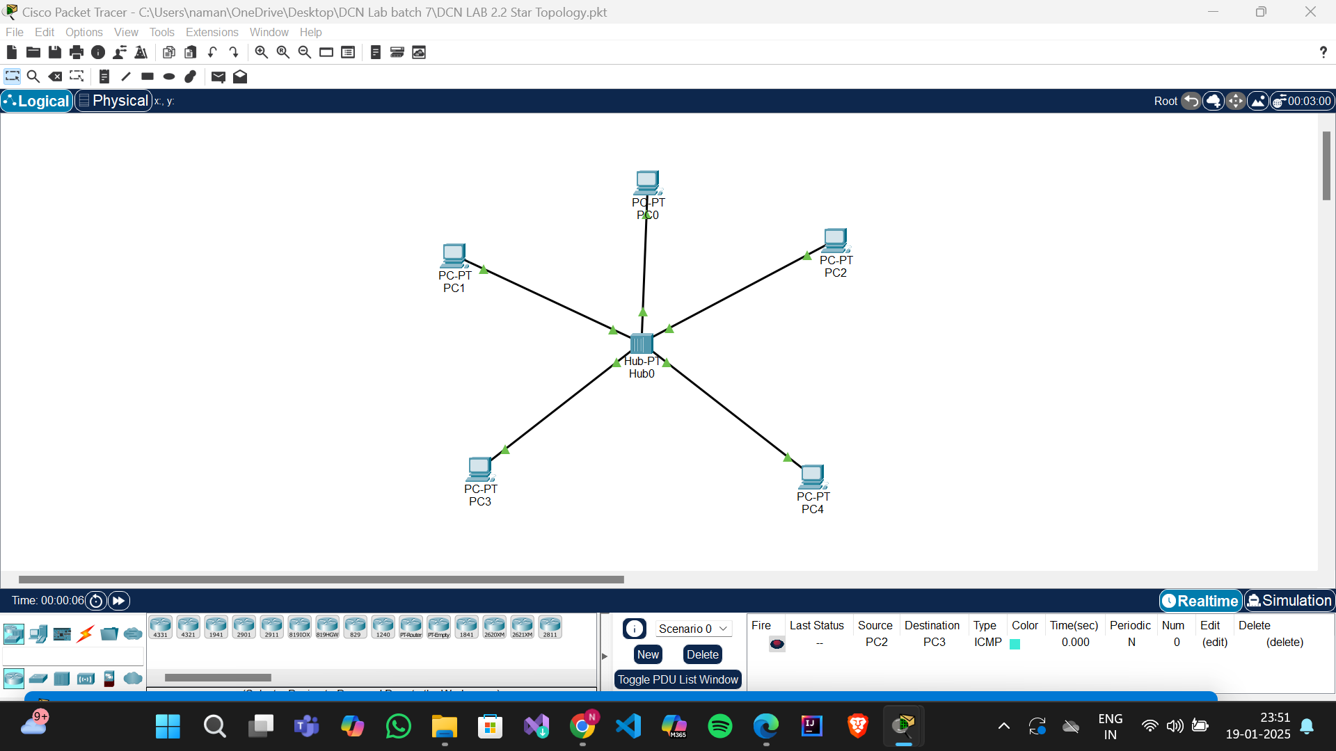

**Mash Topology:-**

Types of Mesh Topology:

1. Full Mesh

* Every device is directly connected to every other device
* Total number of connections = n(n-1)/2, where n is number of devices
* Provides maximum redundancy

1. Partial Mesh

* Only some devices have full connections
* Critical devices usually have more connections
* Balance between redundancy and cost

Working Mechanism:

1. Data Transmission

* Multiple paths available between devices
* Uses routing algorithms to find best path
* Can reroute traffic if a path fails
* Supports simultaneous transmissions between different pairs

1. Routing Intelligence

* Devices actively participate in routing
* Dynamic path selection based on:
  + Network traffic
  + Path availability
  + Link quality
  + Distance
  + Cost metrics

Advantages:

1. Highly reliable and fault-tolerant
2. No single point of failure
3. Multiple data paths provide load balancing
4. Privacy and security (dedicated connections)
5. Easy fault identification
6. Traffic can be rerouted

Disadvantages:

1. Complex to implement and manage
2. Expensive due to many connections
3. Requires more hardware
4. Complex configuration
5. High maintenance cost
6. Installation is time-consuming

Common Applications:

* Wireless mesh networks
* Internet backbone
* Military networks
* Large enterprise networks
* IoT networks
* Wireless sensor networks

Network Management:

1. Configuration

* Each device needs routing configuration
* Security settings for each connection
* Traffic prioritization rules

1. Maintenance

* Regular link quality monitoring
* Path optimization
* Security updates
* Performance tuning

